Episode 130: R-C circuits and other systems

There are many examples of exponential changes, both in physics and elsewhere. Your specification may require that you make a detailed comparison of the energy stored by a capacitor and a spring and of exponential decay in radioactivity and capacitors.
Lesson Summary
- Discussion: Energy stored (20 minutes)
- Discussion: Exponential decrease (20 minutes)
- Student questions: Exponential decrease (30 minutes)
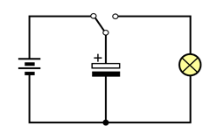

Discussion: Energy stored
Comparing the energy stored by capacitors and springs: The key point in the discussion is that the graphs of charge against pd for a capacitor and force against extension for a spring are both straight lines through the origin. For capacitors, the energy stored is the area under the charge/pd graph. A similar argument can be used to show that the energy stored in a spring is the area under the force/extension graph.
It follows that there are similar equations:
Energy stored in the capacitor = ½ QV
Energy stored in the spring = ½ Fx
Energy stored in the spring = ½ kx ²
Although it is not specifically mentioned in the specifications, the energy can be released steadily but there are many occasions where oscillations occur. Students are likely to have seen this for a spring but may not have seen any electrical circuits involving oscillations. The section could be concluded with a demonstration of this.
Episode 130-1: Electrical oscillations (Word, 108 KB) - see end of document

Discussion: Exponential decrease
Comparing exponential decay for radioactivity and capacitors: You could build up the the connections using contributions from members of the class.
For capacitor decay:
Q = Q₀e^{- t/_CR_}
Current, Δ Q/Q = 1/CR
Time constant, CR: time for charge to fall by 1/e
T _{½}/CR = ln(2)
For radioactive decay:
N = N₀e^{- λ_N_}
Activity, Δ N/N= λN
Half life, T _{½} : time for no. of atoms to fall by ½.
T _{½} λ = ln(2)
Any such comparison needs to highlight the similarities in the patterns for two very different physical processes by comparing the graphs of the decays. (This is a good point to remind pupils that testing for exponentials, either by a constant ratio property or from a log graph, is an important skill.)

Student questions: Exponential decrease
This worksheet has a good survey of a number of processes involving exponential decay: radioactivity, capacitor discharge and more.
Episode 130-2: Exponential changes (Word, 75 KB) - see end of document
Episode 130- 1: Electrical oscillations

Demonstration:
This demonstration shows electrical oscillations in which the capacitor helps to determine the frequency. A comparison with a similar mechanical system is made. The demonstration includes an inductor which may lie beyond your specification.

Apparatus
capacitor(s) 50 – 500 μ F
high inductance coil, choose coils from a demountable transformer kit if available
cell holder with four cells
oscilloscope (or datalogger with voltage sensor)
s.pdt. switch (if available)
leads

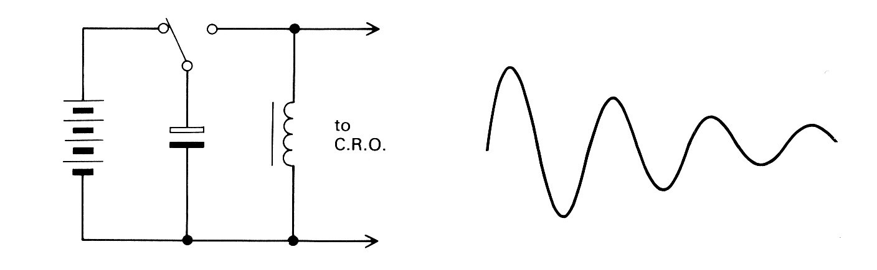

The cells are used to charge the capacitor which is then discharged through the inductor. With the time-base set to a slow speed, decaying oscillations can be observed. Changing the capacitance (or the inductance) will alter the frequency.
If you are able to record the output voltage, this gives a good example of exponentially damped SHM.

The LC circuit can be compared to a mechanical system in which the capacitor is represented by a spring and the inductor acts as a mass [your students will have to be told this].

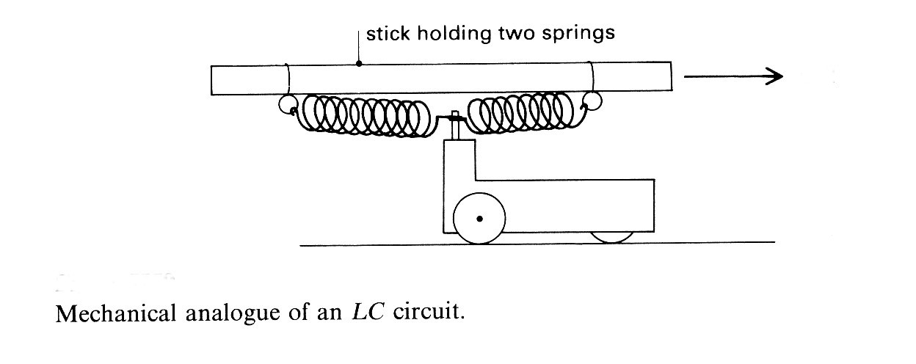

A dynamics trolley is attached to a metre rule by two springs. A gentle motion of the stick can maintain oscillations and at the resonant frequency the amplitude will be quite large. On removing the driving force, the oscillations will die down as in the LC circuit.

External references
This activity is taken from Revised Nuffield Advanced Physics and is an adaptation of experiment H26.

Episode 130- 2: Exponential changes

Many naturally occurring changes are exponential. That is, they follow a pattern in which equal steps result in equal fractional changes. The following are just some of many possible examples.
Attenuation of electromagnetic radiation as it travels through a material (e.g. light in a glass fibre). Equal increases in distance, x, result in equal fractional decreases in intensity, I. Mathematically this can be expressed as
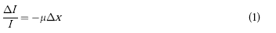
Capacitor discharge through a resistor. The discharge current, I, depends on the pd across the capacitor
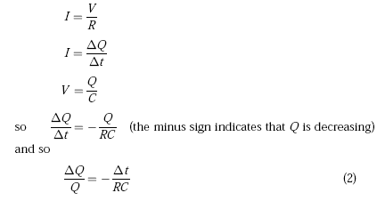
Radioactive decay. The number of nuclei decaying per unit time is proportional to the number of unstable nuclei, N, present in a sample.
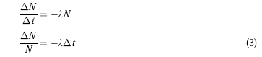
Population growth. The number of new offspring per unit time is proportional to the number of organisms in a population.
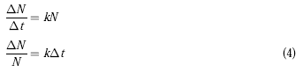
Equations (1), (2), (3) and (4) all have the same form. They differ only in the symbols used and in the sign of the constant on the right-hand side, which is negative for decay with distance or time, and positive for growth. Each of equations (1), (2), (3) and (4) can be expressed in calculus notation, allowing the intervals to become arbitrarily small. Integration then leads to another form of equation for exponential change. For example, equation (1) becomes

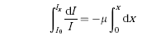
If I₀ is the intensity when x = 0, and I_{x} the intensity after a distance x, integrating between limits gives
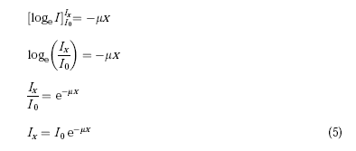

Questions
1. Use calculus and equations (2), (3) and (4) to derive equations for the following:

(a) charge, Q, on a discharging capacitor as a function of time;

(b) number, N, of unstable nuclei as a function of time;

(c) number, N, of organisms in a breeding population as a function of time.

In each of equations (1), (2), (3) and (4), the constant on the right-hand side is related to the time or distance over which a quantity changes by a factor of e (e = 2.718). For example, from equation (5) we have
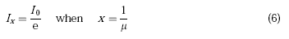
It is often useful to consider the time or distance over which a quantity halves or doubles. Putting Ix = I₀/2 in equation (5) we get
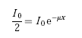
taking reciprocals, cancelling and taking logs to base e gives

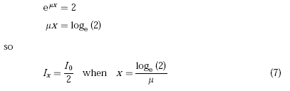
2. Derive expressions for the following:

(a) The time for the charge on a capacitor (i) to be reduced by a factor of e (ii) to halve.

(b) The time for the number of unstable nuclei in a sample
(i) to be reduced by a factor of e
(ii) to halve.

(c) The time for the number of organisms in a breeding population
(i) to rise by a factor e
(ii) to double.

Answers and worked solutions
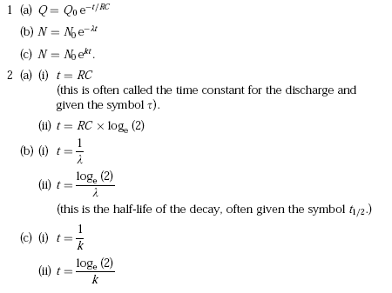

External references
This activity is taken from Salters Horners Advanced Physics, A2, The Medium is the Message, Section MDM, Additional sheet 2

